PRACTICE PROGRAMS OS LAB 27/02/2026

LINEAR SEARCH:
#include<stdio.h>
#include<stdlib.h>
int main(){
int target,size,count=0;
printf("Enter the size of the array:");
scanf("%d",&size);
int arr[size];
printf("Enter the elements of the array:");
for(int i=0;i<size;i++){
scanf("%d",&arr[i]);
}
printf("Enter the target element:");
scanf("%d",&target);

for(int i=0;i<size;i++){
if(arr[i]==target){
count++;
}else{
count;
}

}
if(count!=0){
printf("Element found");
}else{
printf("Element not found");
}
return 0;}
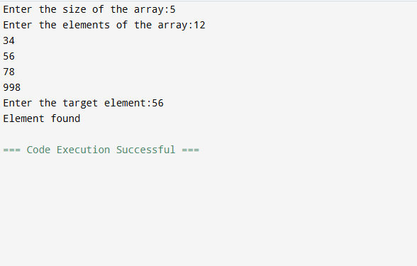

BINARY SEARCH:
#include <stdio.h>
int main() {
int size, target;
printf("Enter size of array: ");
scanf("%d", &size);
int arr[size];
printf("Enter elements (sorted):\n");
for (int i = 0; i < size; i++) {
scanf("%d", &arr[i]);
}
printf("Enter element to search: ");
scanf("%d", &target);
int low = 0, high = size - 1, mid, found = -1;
while (low <= high) {
mid = (low + high) / 2;
if (arr[mid] == target) {
found = mid;
break;
} else if (arr[mid] < target) {
low = mid + 1;
} else {
high = mid - 1;
}
}
if (found != -1)
printf("Element found at position %d\n", found + 1);
else
printf("Element not found\n");
return 0;
}
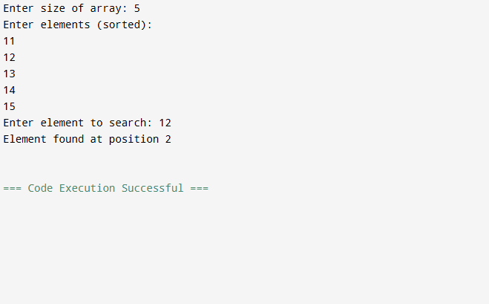

DUPLICATE ELEMENT
#include<stdio.h>
#include<stdlib.h>
int main(){
int target,size,count=0;
printf("Enter the size of the array: ");
scanf("%d",&size);
int arr[size];
printf("Enter the elements of the array: \n");
for(int i=0;i<size;i++){
scanf("%d",&arr[i]);
}
for (int i=0; i<size; i++) {
for (int j=i; j<size; j++) {
if (arr[j] == arr[i]) {
count = count+1;
}
}
if (count>1) {
printf("Duplicate element: %d\n", arr[i]);
}
count=0;
}
return 0;
}

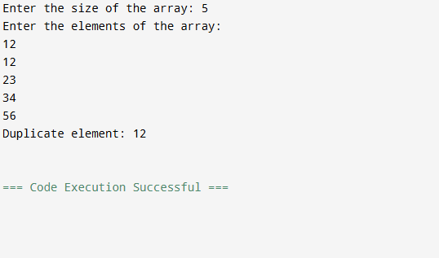

SMALLEST ELEMENT
#include <stdio.h>
int main() {
int size;
printf("Enter the size of the array: ");
scanf("%d", &size);
int arr[size];
printf("Enter the elements into the array:\n");
for (int i = 0; i < size; i++) {
scanf("%d", &arr[i]);
}
int smallest = arr[0];
int position = 0;
for (int i = 1; i < size; i++) {
if (arr[i] < smallest) {
smallest = arr[i];
position = i;
}
}
printf("Smallest number: %d\n", smallest);
printf("Position: %d\n", position);
return 0;
}

